***MORI Auto-Coder* Guide**

**~ A Living Document ~**

**Contents**

The Auto-Coder Explained. . . . . . . . . . . . . . . . . . . . . . . . . . . . . . . . . . . . . . . . . . . . . . . . . . . . pg. 1

The Excel File. . . . . . . . . . . . . . . . . . . . . . . . . . . . . . . . . . . . . . . . . . . . . . . . . . . . . . . . . . . . . . pg. 3

The Transcript. . . . . . . . . . . . . . . . . . . . . . . . . . . . . . . . . . . . . . . . . . . . . . . . . . . . . . . . . . . . . . pg. 4

Helpful tips . . . . . . . . . . . . . . . . . . . . . . . . . . . . . . . . . . . . . . . . . . . . . . . . . . . . . . . . . . . . . . . . pg. 6

Troubleshooting . . . . . . . . . . . . . . . . . . . . . . . . . . . . . . . . . . . . . . . . . . . . . . . . . . . . . . . . . . . . pg. 6

The coding scheme. . . . . . . . . . . . . . . . . . . . . . . . . . . . . . . . . . . . . . . . . . . . . . . . . . . . . . . . . . pg. 7

**The Auto-Coder Explained**

The Auto-Coder is an application (.exe file) that auto-codes MORI transcripts, and can be run from any Windows 10 operating system. Mac OS is not supported at this time.

.xlsx files are the only type of file supported, and you must use the one provided, as it is prepared specifically for this coding.

When opened, it will look something like this:

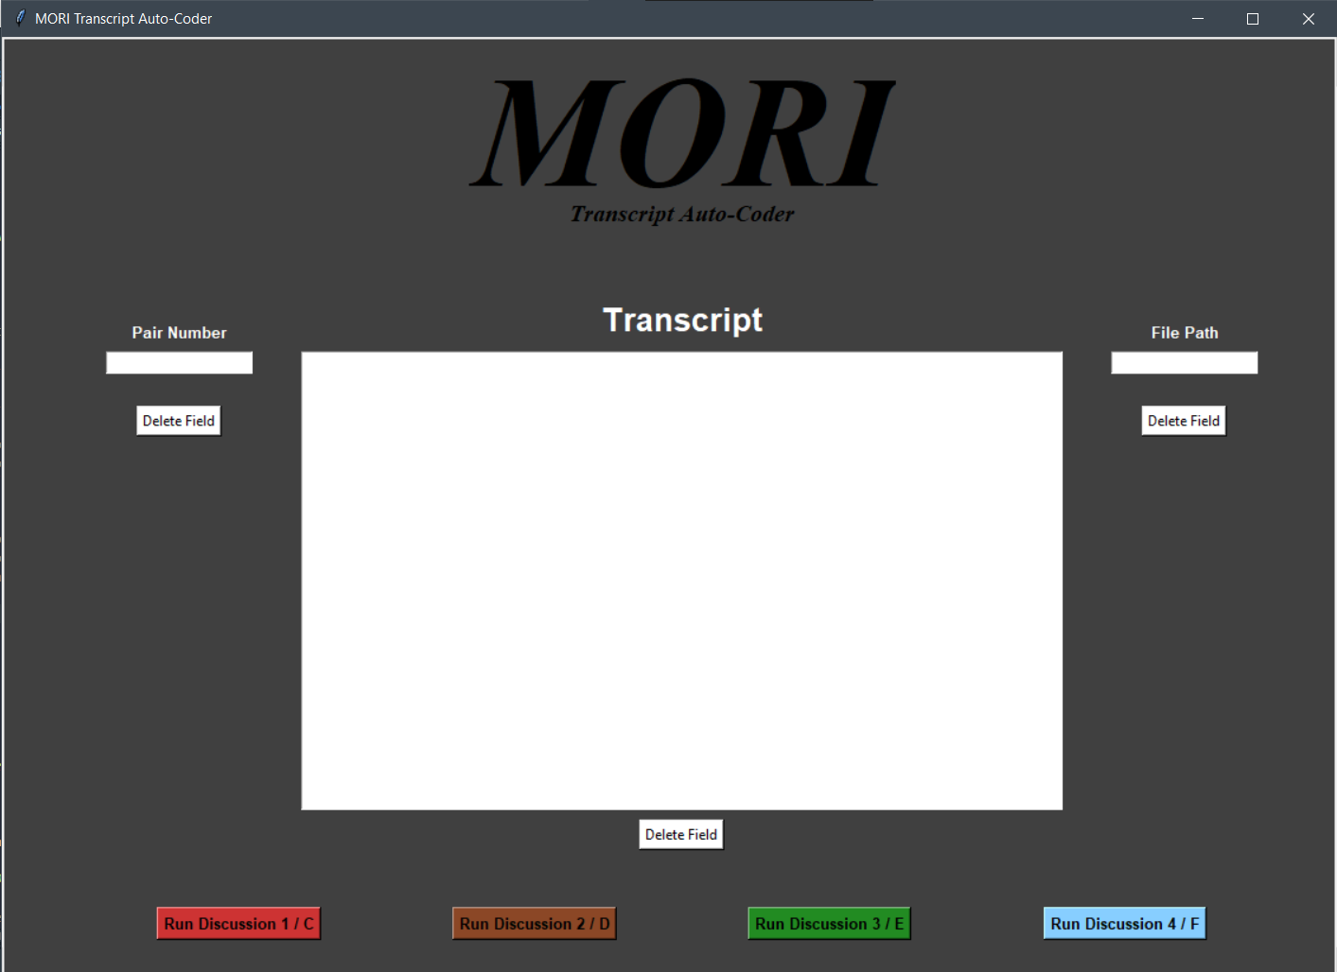

**Entry Boxes**

Under the *Pair Number* heading is a box. This is where you will put in the number for the participant pair.

Under the *Transcript* heading is a box. This is where you will copy/ paste your correctly formatted transcript. Note that right clicking in the entry box does not work, but **Ctrl+C** and **Ctrl+V** does. You should be able to scroll through your transcript.

Under the *File Path* heading is a box. This is where you will put your file path to the designated excel sheet. If your Excel sheets are in a different location from the Auto-Coder application, then you will need to paste in the entire file path. For example:

**C:\Users\your_name\Desktop\code test.xlsx**

However, it is much easier if the application is in the same location as the excel sheet (for example, on your Desktop, or in Documents). If they are, then you can simply type in the name of your Excel sheet into the box, without the file path:

**code test.xlsx**

Once finished with the 3 entry boxes, click one of the buttons on the bottom of the page. If it is Discussion 1/Discussion C that you are attempting to analyze, press the “Run Discussion 1/C” button. Then, check your excel sheet.

NOTE: You do **NOT** need to close the program down after each run. To delete the text in the box, select the *Delete Field* button. You can simply paste in a new transcript, file, or pair number, and then press a discussion button.

**The Excel File**

The Excel file is an important and necessary part of the auto-coder.

ALL blank excel files will look like this:

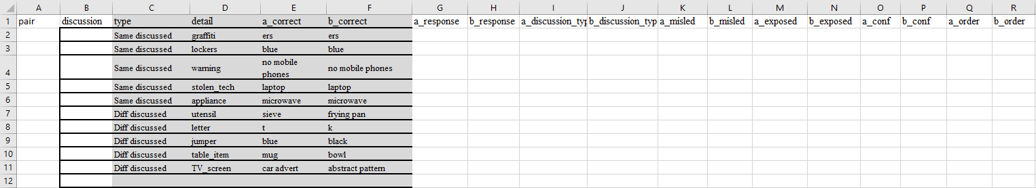

Do not worry about the details – they will be changed by the auto-coder. At the bottom of the excel file, make sure that the sheets are intact:



**Data**

The ***pair***column will be filled by user input in the GUI.

The ***discussion***column will be filled by the GUI, dependent upon which Discussion button is pressed.

The ***type****,* ***detail****,* ***a_correct****,* and ***b_correct***will be automatically changed to the necessary details by the excel sheet when the ***discussion*** column is filled.

All other columns will be filled by the auto-coder.

If all is completed correctly, then it will looks like this:

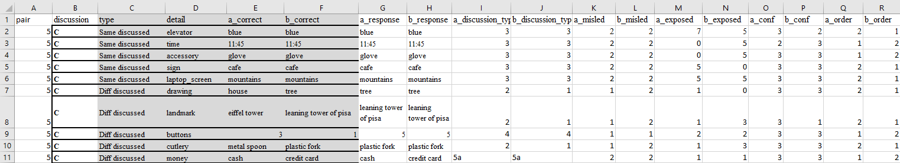

**Absolutely Gorgeous…**

**Transcript Format**







question 1.

experimenter: What was the colour of the sky?

person 2: i want to say it was blue or green.

person 1: i think it was blue.

person 2: Ok i - i feel like it was, sure yea let’s go with blue.

experimenter: ok so both of you guys are going with blue there?

person 1: yes

person 2: (thumbs up)

P1 conf: h.

P2 conf: m.

P1 F: D. 

P2 F: D. 

~

**Plain Example**

question 1.

person 2: a glove was on the ground, so I think A.

person 1: i think it was a watch.

person 2: ok i - i feel like it was, sure yea let’s go with watch, I guess.

experimenter: ok so both of you guys are going with D, watch there?

person 1: yes.

person 2: (thumbs up).

p1 conf: h.

p2 conf: m.

p1 F: D.

p2 F: D.

~

**Helpful Tips**

1. To reduce the chance of capitalization errors, when transcribing you should disable auto-capitalization in your word processing software.
2. ~~There cannot be a space after any of the tildas (~)~~
3. Do **NOT** transcribe question 0 (the practice question)
4. Numbers can be written as words (e.g., three) or numerals (e.g., 3).
5. You may end lines for each person with periods (and other punctuation), and can have periods in the middle of lines for each person (i.e., you can transcribe speech as it would be written).
6. Leave blank any confidence ratings/final answers that aren't given (shouldn’t actually exist though)

**Troubleshooting**

In the likely event something went wrong, it’s most likely the tedious format.

**Pair isn’t showing up**

Uh-oh. Are you inputting it into the application? If yes, then the application is broken.

**Discussion is wrong/ not showing up**

Uh-oh. Are you inputting it into the application? If yes, then the application is broken.

**I think some of the Misled or Exposures are wrong**

Are the grafitti, the letters, time, or the answers in capitals/ numerical format?

**a_response / b_response isn’t showing up / correct**

Is it formatted correctly, like this? 🡪 P1 F: A.

🡪 P2 F: A.

Is there a tilda (~) separating each question?

**a_conf / b_conf isn’t showing up / correct**

Is it formatted correctly, like this? 🡪 P1 conf: m.

🡪 P2 conf: h.

Is there a tilda (~) separating each question?

**Speaker order is wrong**

Is it formatted correctly? With periods, and beginning with “question X”

**------------------THE CODING SCHEME ------------------**

The following section details the coding scheme that the auto-coder uses

The following variables are coded by the Auto-Coder program using formatted transcripts:

**Discussion type:**

Categorizes the pair’s agreed upon final answer. A response is considered a final answer when:

1. Both participants explicitly declare the same final answer (e.g., "final answer is blue")
2. One participant explicitly declares a final answer on behalf of the pair (e.g., "our final answer is blue") and the partner appears to agree
3. When prompted for a final answer, both participants declare the same answer (e.g., “blue”)
4. When prompted for a final answer, one participant declares an answer on behalf of the pair (e.g., “blue”) and the partner appears to agree
5. Both participants explicitly declare different final answers (e.g., "final answer red" and "final answer purple")
6. When prompted for a final answer, both participants declare a different answer (e.g., “blue” and “purple”)

Note: all other scenarios will be coded as “no response” under 5(f) below. Points 5 and 6 will be coded as pair provided separate answers under point 5 below.

Each of the 10 discussion items will be categorised into one of the following categories:

**Final answer**

1. Pair agreed on **participant’s** witnessed detail

2. Pair agreed on **partner’s** witnessed detail

3. Pair agreed on **joint** witnessed detail

4. Pair agreed on other **inaccurate** detail (e.g. detail on the 5AFC that neither participant saw or detail that was not mentioned on the 5AFC)

5. Pair provided separate answers

(a) participant provided participant-witnessed detail

(b) participant provided partner-witnessed detail

(c) participant provided other inaccurate detail mentioned by partner (detail mentioned on the 5AFC that neither participant saw, or detail that was not mentioned on the 5AFC)

(d) participant provided other inaccurate detail NOT mentioned by partner (detail mentioned on the 5AFC that neither participant saw, or detail that was not mentioned on the 5AFC)

(e) participant provided non-relevant detail

(f) participant provided no response

**Exposure to misinformation**

**Step 5:** For each discussion item and each participant, the Auto-Coder program will code whether the participant was exposed to misinformation **at any point during** the discussion.

**Exposure to misinformation**

1. Non-discussed (not exposed to any information, auto-coded)
2. Exposed to the partner’s witnessed detail
3. Exposed to an incorrect detail that neither participant witnessed
4. Exposed to the participant’s witnessed detail
5. Both 1 & 2
6. Both 1 & 3
7. Both 2 & 3
8. All of 1, 2, & 3

**If a person mentions a detail, but does so in the negative, e.g., Person A says “I *didn’t* see a glove”, and “glove” is incorrect for both Person A and B, it still counts as exposure to misinformation (i.e., a code of 2).**

**Misled status**

For each discussion item, the Auto-Coder will determine whether or not a participant was misled by their partner.

Participants will be coded as being **misled by their partner** using the following algorithm:

* 1. Check participant’s final answer—is it incorrect? If yes, proceed.
  2. Check discussion—was incorrect final answer mentioned explicitly by partner? If yes, misled.
  3. Otherwise, not misled.

Note: If a participant is exposed to more than one detail, both details will be used to determine whether or not a participant was misled by their partner (e.g., if a participant is exposed to both a partner-witnessed detail and an inaccurate-detail, the partner will be considered to have been misled if they have agreed on the partner-witnessed detail OR the inaccurate detail)

Note (in cases where a pair agrees on an inaccurate final answer): If, before a pair declares a final answer, a participant does not explicitly mention an inaccurate detail but agrees with an inaccurate detail mentioned by their partner, this participant will be coded as “misled” and their partner will be coded as “not misled”.

**e.g., A reports “5 buttons” (incorrect for A, incorrect for B), B response with “I agree”, A is not misled (Because B did not explicitly mention “5 buttons”), B is misled**

**e.g., A reports “5 buttons” (incorrect for A, incorrect for B), B response with “Yes, 5 buttons”, both are misled**

**e.g., A reports “5 buttons” (correct for B, incorrect for A), B reports “3 buttons” (correct for A, incorrect for B), A agrees with “3 buttons”, B agrees with “3 buttons”. A is not misled, B is misled (Because A explicitly mentioned “3 buttons”)**

All other scenarios will be coded as being **not misled by their partner**.

**Speaker order**

For each discussion item for each participant, the Auto-Coder will determine whether the participant spoke first or not:

**Order of speech**

1. Participant spoke first

2. Partner spoke first

**Step 7:** For each discussion item for each participant, the transcribers will rate how confident the participant appears in their memory of each item.

**Confidence**

How confident does the participant appear to be in their memory of the detail:

1. Not at all confident
2. Moderately confident
3. Very confident

We considered the use of more objective criteria (e.g., certain verbal/non-verbal cues), but based on previous experiences trying to do this we stuck with subjective ratings.